Introduction to programming

Variable assignment

Task: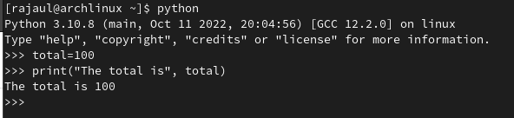

Task: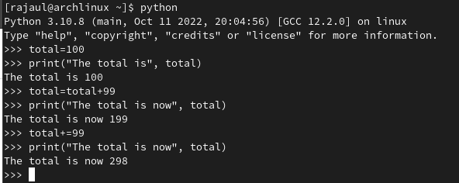

Task: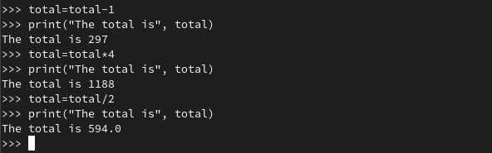

Task: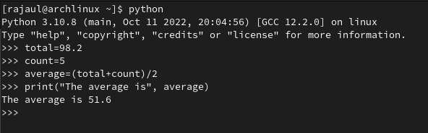

Data-Types

Task: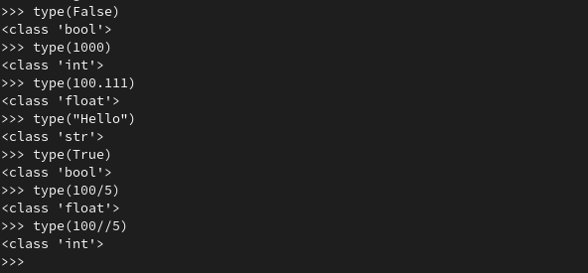

Task:

## Calling Built-in functions

## Task:

## 

## Getting input from the user

Task:

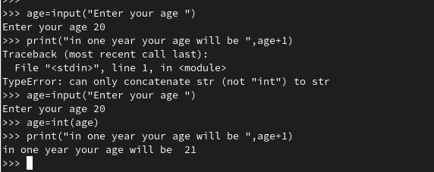

Task:

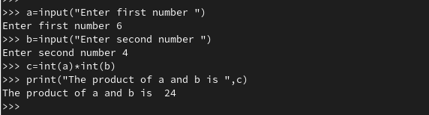

Single, Double & Triple Quotes

Task:

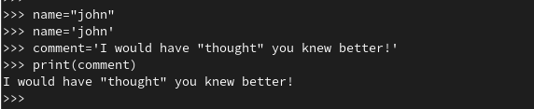

Escape Sequences

Task: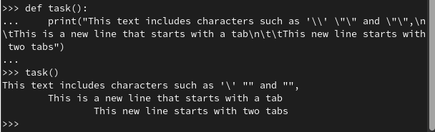

Task: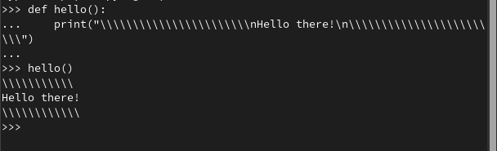

Using Triple Quotes

Task: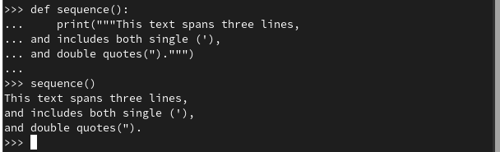

Indexing and Slicing

Task: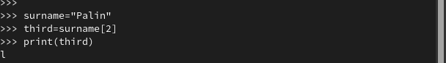

Task: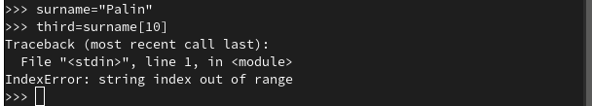

Task: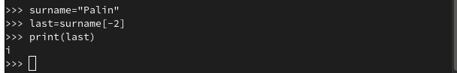

Slicing

Task: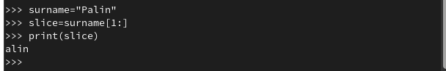

Task: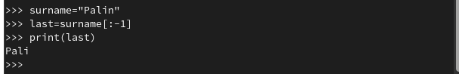

Introducing List

Task: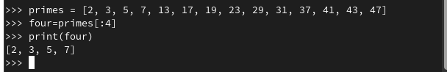

Mutable and Immutable Types

Task: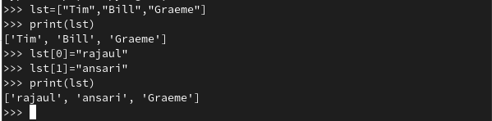

Task: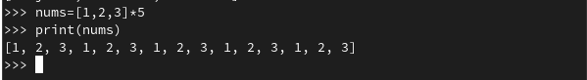

Key Terminology

* Assignment: it is used to set a value to a variable name.
* Data-Type: A data-type indicates the nature of the value, i.e. does the value represent a whole number? A decimal number? A piece of text? Etc.
* Argument: Argument is a value that is passed between programs or functions.
* Indexing: An indexing is a method of sorting data by creating keywords or a listing of the data.
* Slicing: Slicing operations are similar to indexing type operations but are more powerful, and able to access multiple characters rather than single characters only.
* Mutable: A mutable value can be changed after it has been created.
* Immutable: An immutable value can never be changed once it has been created.